How to turn responsibilities into accomplishments

Use numbers or metrics
The most surefire way to transform a responsibility into an accomplishment is by adding specific numbers or metrics. This way, you aren’t just saying what you did (created a performance recording template); you’re demonstrating how effectively you did it (reduced preparation time by 80%). Not only do metrics like this help you stand out from other candidates with similar experience, they provide an objective measure of your performance and allow hiring managers to more clearly imagine how you would perform in the new role.

Be specific
One of the worst mistakes you can make on your resume is being vague or generic. Metrics can help with that, but you need to make sure you’re also being specific when you talk about your actions. An accomplishment like “implemented strategy that increased customer base by 1000+ customers” sounds impressive on the surface, but while the numbers are specific, what you actually did remains undefined. Don’t leave hiring managers wondering about how you did something (or whether you were even responsible for the result in the first place).
Describe your actions! For example, “designed and launched customer affiliate program, which led to 1000+ new customers in 6 months and 40% reduced cost-per-acquisition” is specific not just about the end result, but about how you achieved it and what skills you used to do so.

Frequently asked questions

What are examples of accomplishments for students?
If you’re a current student or recent graduate, you still use accomplishments from your studies. Generally, you don’t want to fill your resume up with coursework, but things like university or personal projects, extracurricular activities, internships, and student organizations can all work. It’s okay that these aren’t strictly in a professional context — the trick is to treat them the same way, by pulling out what you’ve accomplished and adding numbers or metrics where you can.
https://resumeworded.com/blog/resume-accomplishments/

You might not have a projects section on your resume — and that’s okay. Including projects on your resume is entirely optional, but it can be a good idea if you’ve completed any personal or educational projects that highlight transferable skills or are relevant to the job you’re applying for.

What you need to know about including projects on your resume
There is a place for both personal and educational projects on your resume. Educational projects might include projects you completed at university, during further education, or as part of a professional or career change program. It doesn’t include regular coursework, unless it was particularly outstanding (ie. award-winning).
Personal projects can be anything you’ve completed in your own time, as part of a side venture, or during the course of volunteer work. If you’ve completed a large number of projects — for example, running your own freelance or consulting venture — you might want to consider including that in your work experience section.
If you choose to include projects on your resume, they should be formatted like your regular work experience. Use bullet points to emphasize your skills and accomplishments using action verbs and quantifiable metrics.

When to include projects on a resume

If you lack relevant work experience
If you don’t have a lot of paid work experience, projects can be a good way of demonstrating your skills and experience. If this is the case, the projects you choose to include need to be both relevant and significant — remember, it’s better to have a very short resume than to pad it out with unnecessary fluff.

If you’re changing careers
If most of your paid experience is in a different role or industry, projects can help demonstrate your competence with a more relevant skill set. This is especially true if you’re trying to break into a highly specialized or technical field. For roles involving software development, coding, or data analysis, a few relevant projects may even be more worthy of inclusion on your resume than a lot of work experience in a different industry. If this is your situation, consider dropping some of your older or less relevant work experience in favor of a dedicated projects section that can highlight your hands-on experience with specific technical skills.

If you’re a student
Current students or recent graduates without a lot of paid work experience can use university projects to highlight your relevant skills in a more practical setting. If this is the most relevant experience on your resume, it’s fine to list your education section first and use projects to bulk it out.

Getting past Applicant Tracking Systems
Some Applicant Tracking Systems (ATS) or other types of resume screening will automatically reject candidates who lack certain skills or keywords. To get around this, you can use projects as a way to legitimately include skills that are required by the job listing if you have no other way of demonstrating them. Again, this can be particularly important if you’re trying to break into a technical field, so it’s worth taking the time to develop those hands-on skills before you start applying.

Do’s and don’ts for projects on your resume
Do:
- Use projects to demonstrate hard skills. Technical skills like programming, proficiency with specific software programs, or experience with social media marketing are all appropriate skills you may want to highlight.
- Tailor the projects to the specific job you’re applying for. Not every project is relevant to every role, and not every single task within a specific project is related to all roles either — be selective about what you include.
- Use hard numbers and metrics whenever you can. If you attended a coding boot camp, mention the specific programming languages you learned. If you used Facebook ads to sell your craft projects, state how much you were able to improve sales. Always be specific about what you achieved, not just what you did.
Don’t:
- Don't use projects for soft skills like communication or leadership. These skills are easy for anyone to claim and difficult to quantify, so you’ll want to use more relevant examples of how you’ve demonstrated these in a professional setting.
- Don't include projects in your regular work experience section. No matter how hard you’ve worked on them, they lack the accountability and oversight that paid work experience requires, so don’t try to frame them as something they aren’t.
- Don't include projects just to bulk up your resume. Only include them if they’re truly relevant to the role and will strengthen your candidacy.

How to feature projects on your resume
So, you’ve decided to include one or two well-chosen projects on your resume — but how do you format them? Here are a few practical examples you can follow.

In a dedicated projects section
If you have the space for it on your resume and you have one or more significant projects you want to make a focal point, having a separate section for your projects may be the way to go.
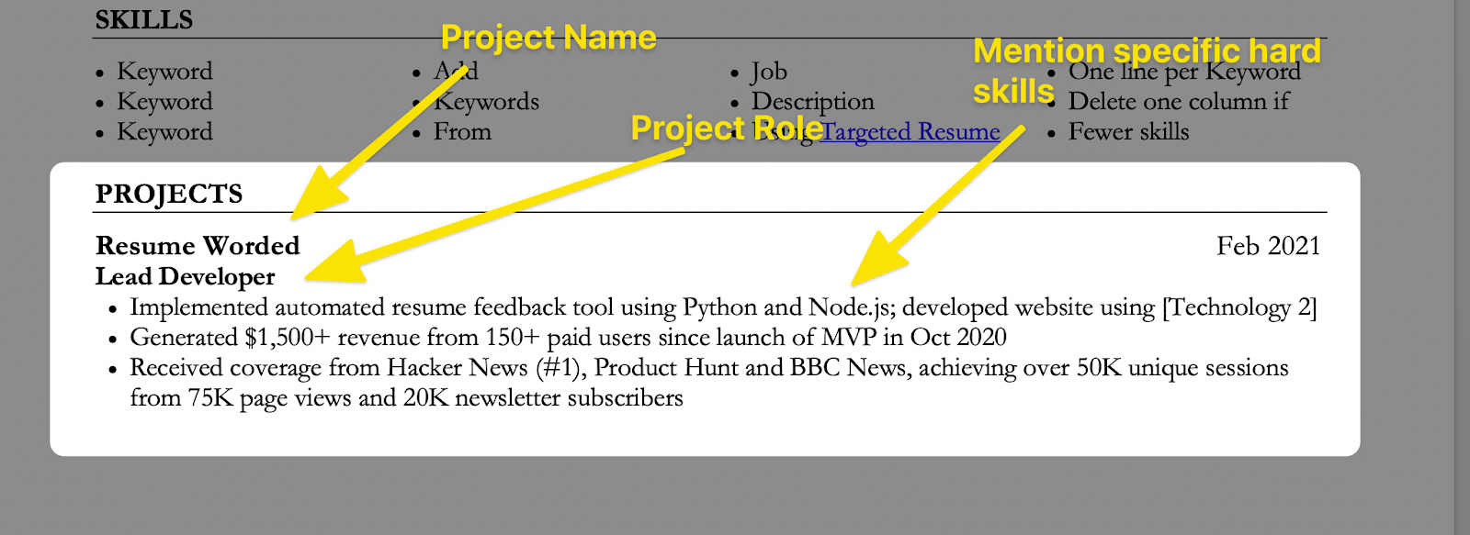How to list a project in a dedicated project section on your resume
If you decide to give your projects their own section, this should be formatted in the same way as your work experience. List the project name and your specific role, then use bullet points to highlight the hard skills you used.
Remember to begin each bullet point with an action verb and use numbers to demonstrate the impact of your role whenever possible.
More at
https://resumeworded.com/blog/projects-on-resume/ Aug 6 2021

